1) Timeline of remaining tasks

2) Summary of performance of current system:

Our current implementation of our system utilizes the KNN and Random Forests classifier. In both cases we explored a monocratic filter that highlights the lines in the hands and creates a better contrast between the hand and background. In addition to this, we also performed a transformation from RGB to HSV on our images. By specifically using the saturation characteristic of an image, we had a better means of differentiating the hand from the background as well. Upon having an effective means to filter the hand from background, our results are as shown.

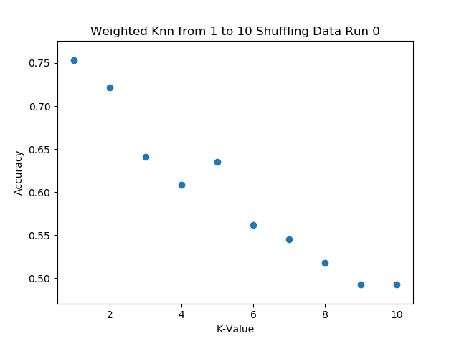

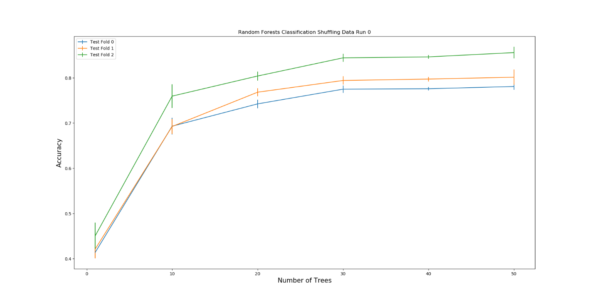

Our Random Forest classifier performed more consistently and yielded a higher accuracy than our KNN algorithm. As a result, we will continue to use the random forest classifier and not the KNN.

3) Plan to avoid overfitting:

We will supplement our dataset with other ASL datasets online. We will perform all the necessary modifications of the images such as rescale and processing steps to ensure the usability of the images within our current system.

4) Other updates:

We were pleasantly surprised by the performance of our system. It is possible that the diversity amongst our group members contributed to a better operation and high classification accuracy. However, we will continue to be diligent in our approach and not assume that our final performance will necessarily parallel our preliminary trials. One of the ways we will tackle this issue is by exploring other classifier methods such as a convolutional neural network.

Furthermore, we will investigate Pytorch and decided if we should make that change to it permanently or continue to use Sci-kit image.

5) Team Effort Percentages

|  |  |
| --- | --- |
| Team Member | Percent |
| Rosemond Fabien | 30% |
| Trung Tran | 31% |
| Michael Barnard | 31% |
| Nikita Buslov | 8% |